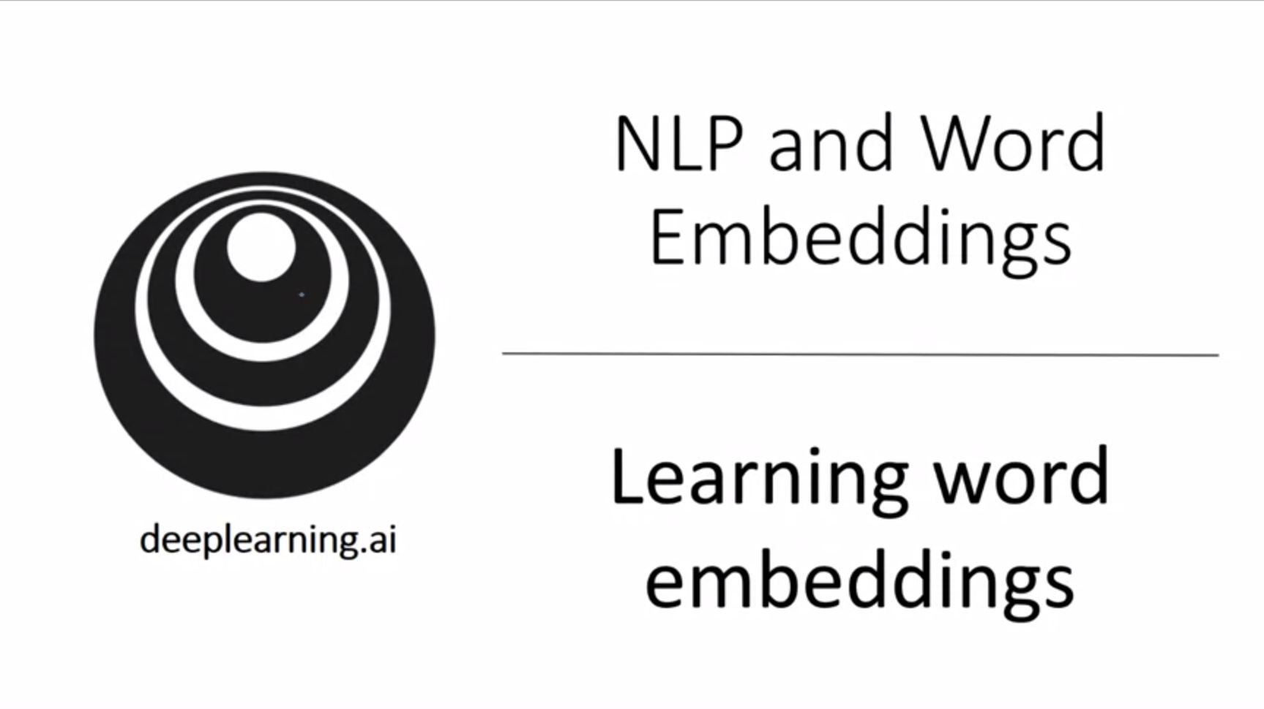

In this section we learn about concrete algorithms to learn word embeddings.

In the history of embedding algorithms people started with very complex algorithms and they became simpler and simpler over time.

We will start with a bit complexer algorithms from the past.

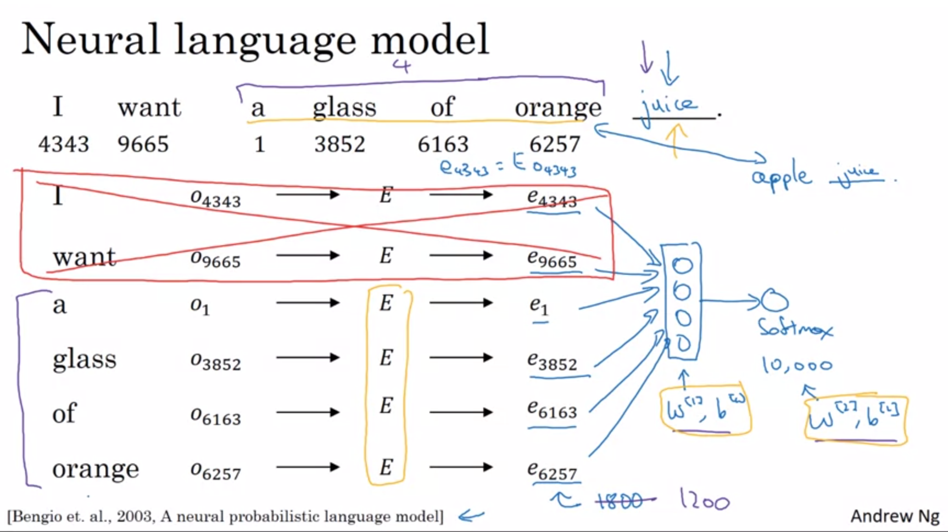

Let’s say we are building a language model with a neural network.

We have a sentence and for each word the index in the vocabulary.

Building a neural language model is a reasonable way to learn a set of embeddings. Idea due to the paper on the bottom of the slide.

Start with a 1-hot vector to represent the words. Obtain the embedding vector by multiplying the 1-hot vector with matrix E.

Feed all of the embedding vectors into a neural network. The neural network feeds into a softmax and classifies between the 10k words of the vocabulary. It should predict “juice” in this case.

Embedding vector layer would have a dimension of 6 * 300 (6 words and 300D embedding).

What is more commonly done is to define an historic window for the prediction (e.g. previous 4 words) -> 4 * 300D.

Having a fixed history allows us to deal with arbitrarily long sentences.

Use the same matrix E for all the words.

Use backprop to perform gradient descent to maximize the likelihood of the training set (predict next word based on previous 4 words).

This algorithm will learn decent word embeddings. It is in the algorithm’s interest to learn similar embeddings for orange juice and apple juice to maximize the likelihood.

Let’s now generalize this algorithm and make it a bit simpler.

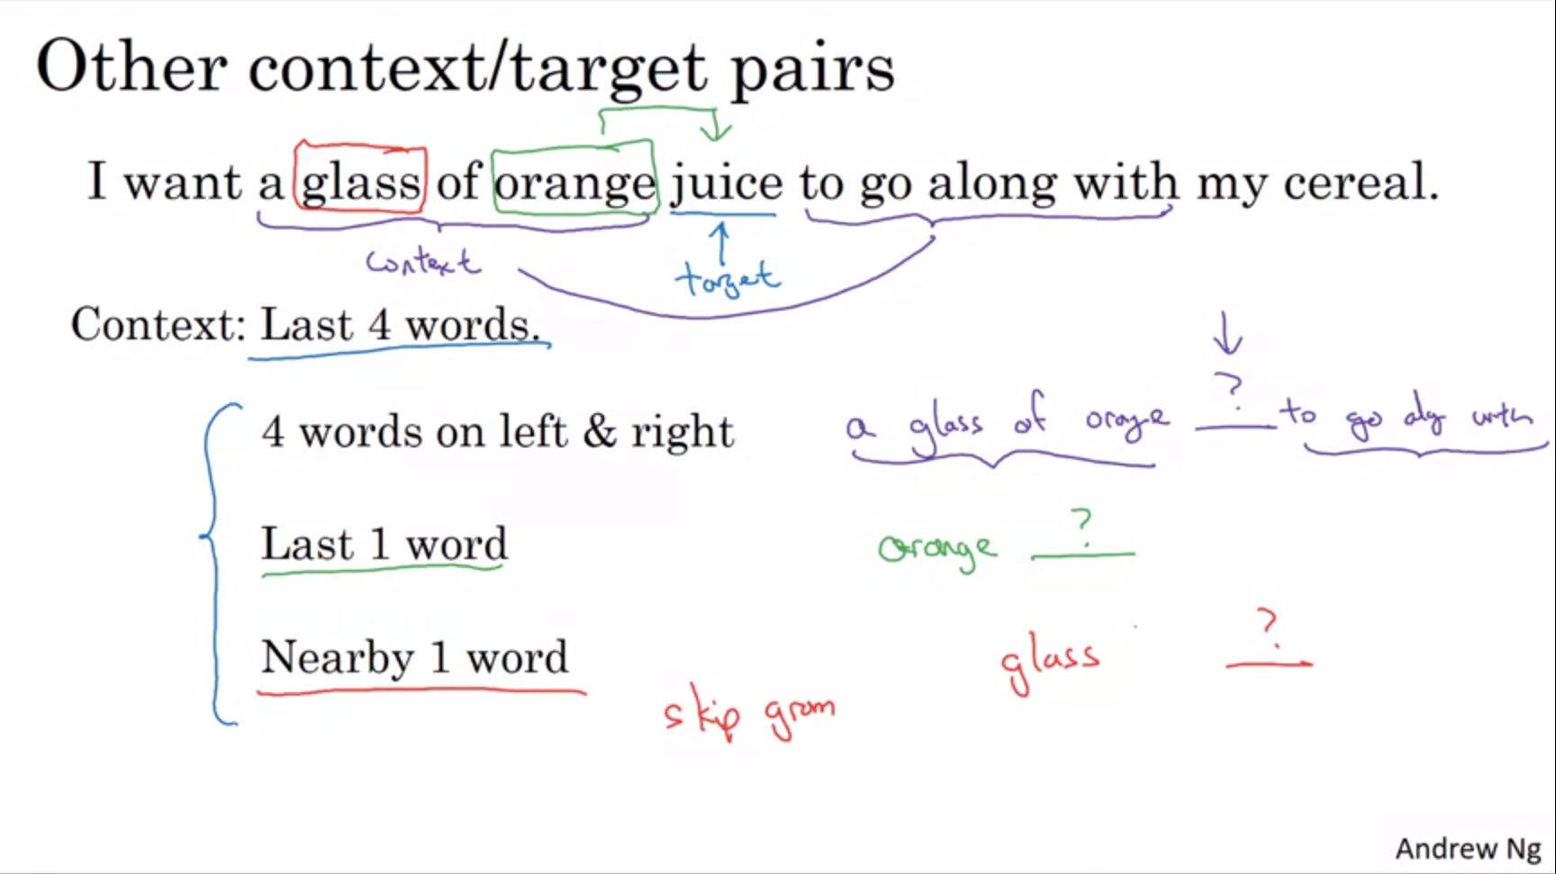

We now have a bit a longer sentence. We have a target and a context. Researchers have experimented with different types of context. For language models it is natural to have a few words before the target word as context. But in theory we can use other contexts, e.g. 4 words on the left and on the right -> pose the learning problem as predicting the word in the middle.

A simpler context could be just to use the last 1 word.

What works surprisingly well is to take nearby 1 word (skipgram model). This is much simpler than using a 4 word context but it works remarkable well for calculating word embeddings.

Now we will use even simpler contexts and algorithms.

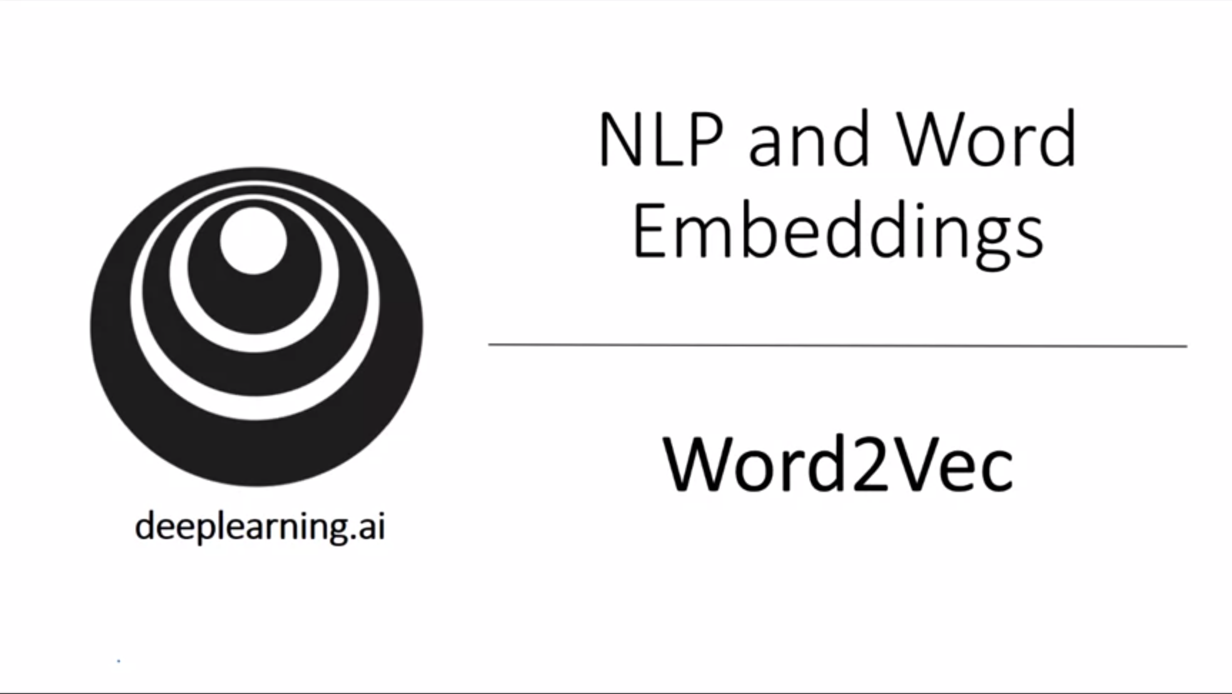

So far we have seen that we can learn a neural language model to learn word embeddings. Now we will see the word2vec algorithm which is a simpler and computationally more efficient way to learn embeddings.

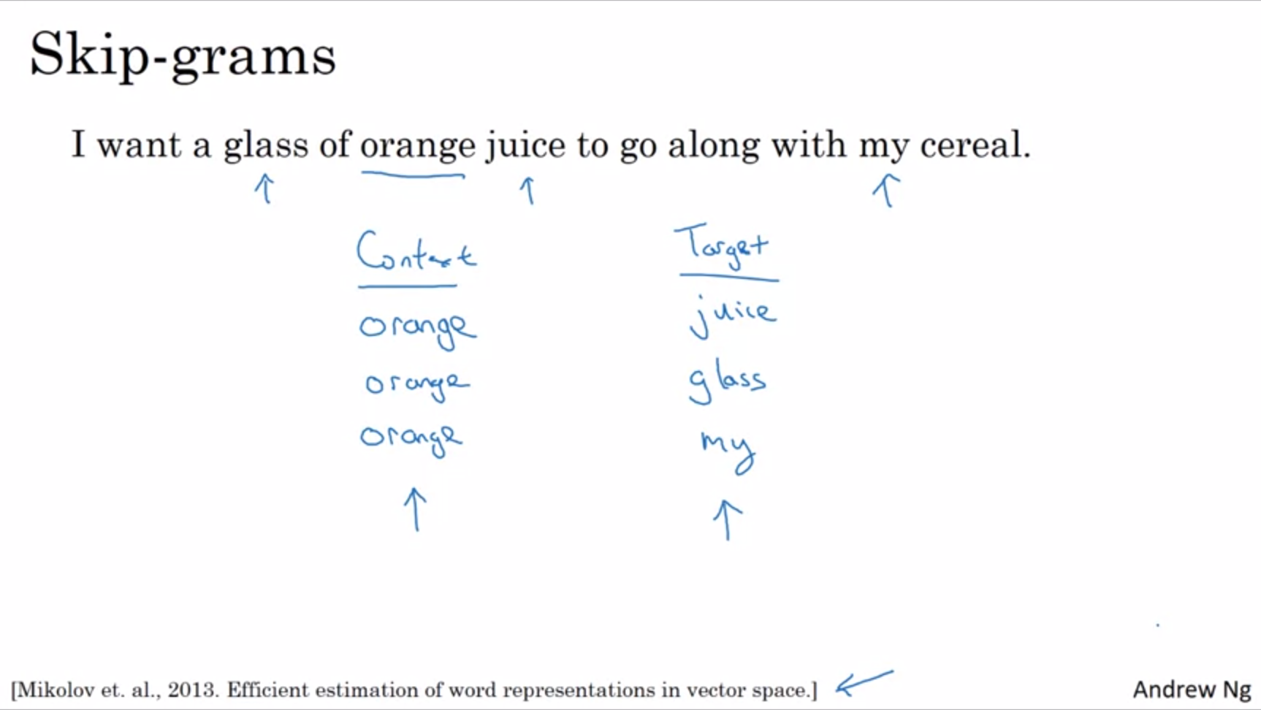

Come up with a few context to target pairs to create a supervised learning problem.

Rather than having the context always be the 4 words previous to the target, we will randomly pick a word to be the context word. Within a certain window, e.g. 5 words, we also pick another random word to be the target word.

Learning problem: given a context word, predict randomly chosen word within a +-10 word window. This is not an easy learning problem, but the goal of this supervised learning problem is not to do well on the prediction per se but to use this learning problem to learn good word embeddings.

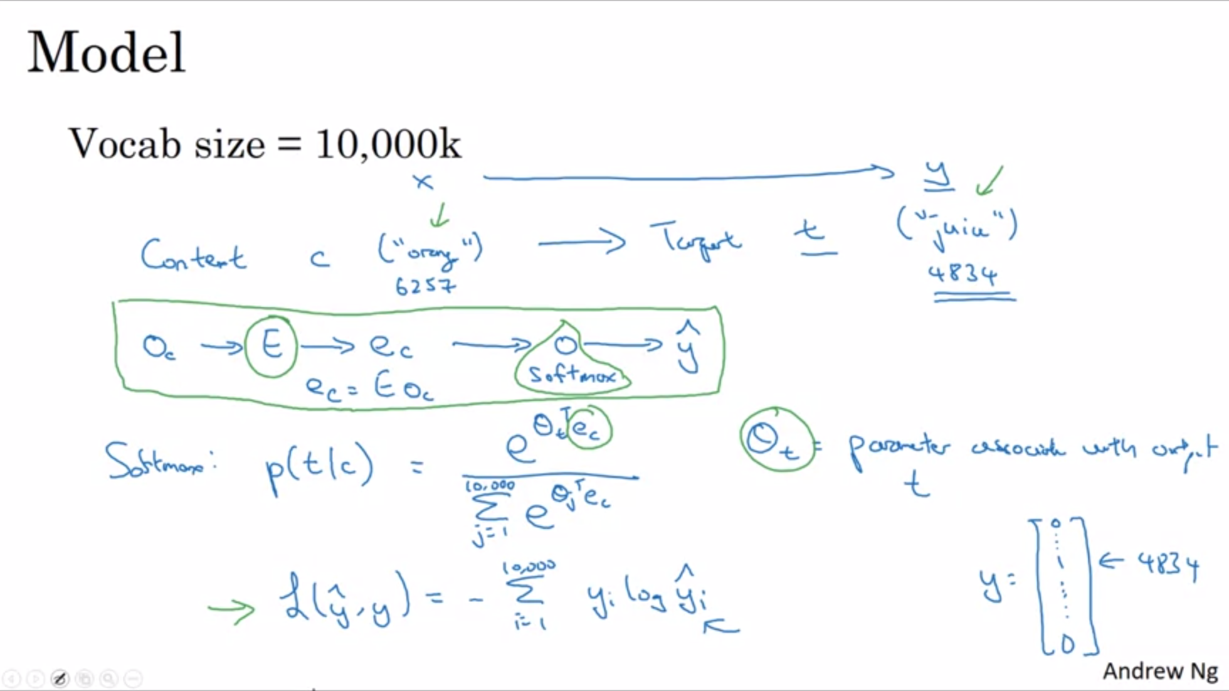

We continue to use our 10k vocab size. Some models have been trained on vocab sizes >1M words.

Start out with 1-hot vector of the context word and multiply with the matrix E to get the embedding vector e. Feed embedding vector to softmax unit that outputs y_hat.

Theta_t: parameter associated with output t.

We have left out the bias term for the softmax.

Loss function as usual for softmax. Target vector y is a 1-hot encoding. Similarly y_hat is a vector of probabilities for all target words.

Matrix E has a lot of parameters and softmax unit also has parameters.

If we optimize for the softmax loss function we get a pretty good set of embeddings with this skipgram model.

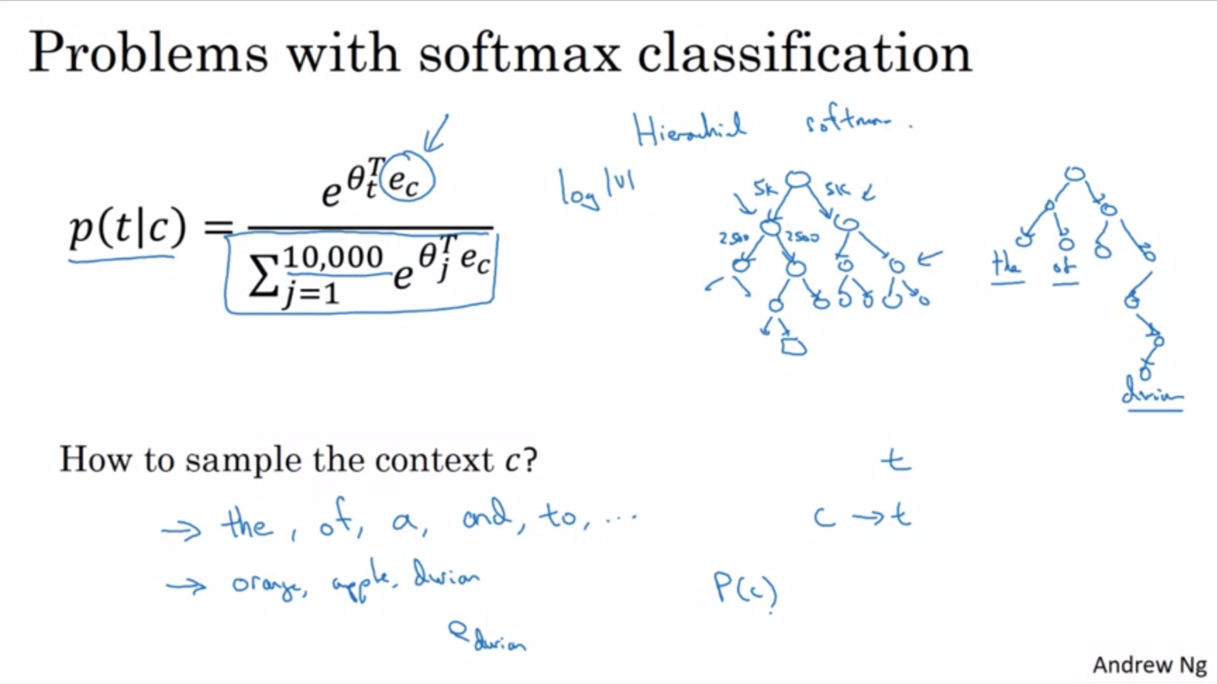

There are a couple of problems with the skipgram approach.

The primary problem is computational speed since a sum over all 10k words needs to be calculated for softmax. This gets worse with a bigger vocabulary size.

There are a few solutions to this. One is the hierarchical softmax -> First you have a classifier that tells you whether the word is in the first 5k or the last 5k of the vocabulary and so on until you have one specific word -> tree of binary classifiers.

A tree like this scales with log of the vocab size instead of linearly with the vocab size.

In practice the hierarchical softmax classifier does not use a perfectly balanced tree. It can be developed so that the common words can be at the top whereas the less common words can be buried much deeper in the tree (see top right of the slide) -> there are many heuristics to build the tree like this.

More details can be found in the paper referenced on the first slide of the section.

The next section will cover a different method called negative sampling which is even simpler and works very well for speeding up the softmax classifier and its problem with having the sum over the whole vocabulary in the denominator.

How to sample the context c? Uniformly at random from a training corpus. Some words appear extremely frequently like “the”, “of”, “a”. Other words like “orange, “apple”, “durian” do not appear that often. Maybe we do not want our training set be dominated by frequently occurring words because we want to update all embeddings.

In practice there are different heuristics for sampling from the training corpus instead of uniform random sampling in order to balance out common words with less common words.

In the original paper by Mikolov there are two versions of this word2vec model: skipgram and cbow (continuous bag of words model).

Cbow takes the surrounding words as context and the middle word as target. This algorithm has some advantages and disadvantages.

The key problem of the skipgram algorithm is that the softmax is very expensive to calculate as mentioned earlier. We will now look at an algorithm that modifies the training objective to make it much more efficient.

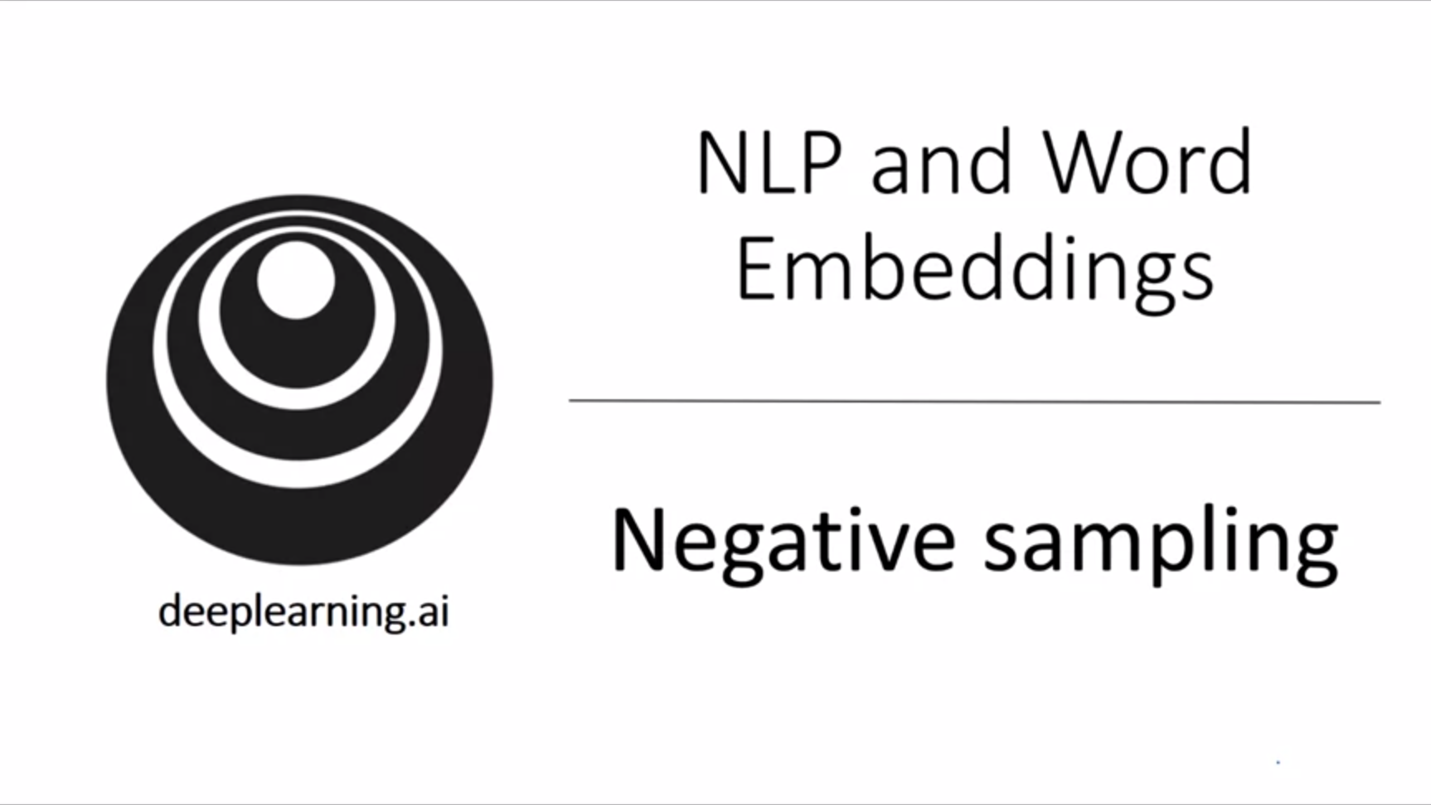

We have seen how the skipgram model allows us to construct a supervised learning task to map from context to target words to learn an embedding. However the disadvantage was the computational cost incurred by the softmax.

Negative sampling allows us to do something similar as the skipgram algorithm but much more computationally efficient.

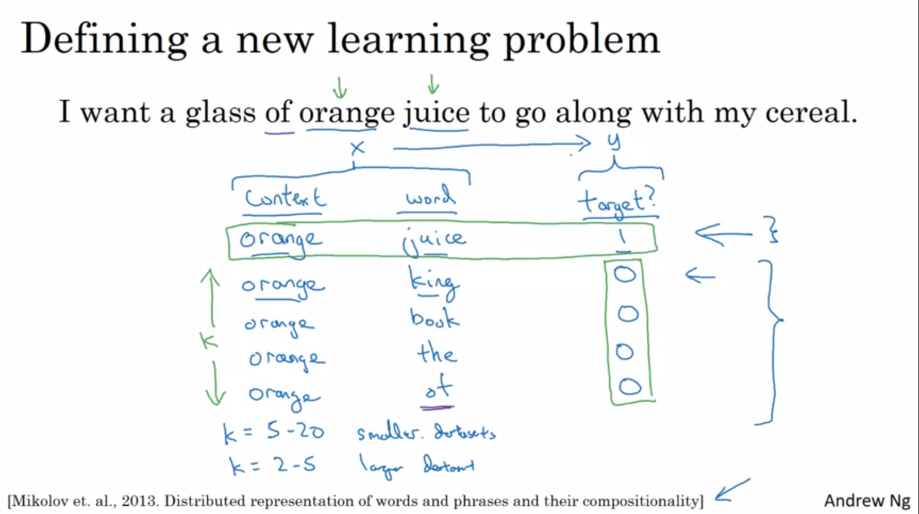

Most of the ideas presented in this section are due to the paper mentioned on the slide.

We will create a new supervised learning problem. Given a pair of words we will predict whether this is a context-target-pair. We sample the pair of words and label it with 1 or 0 depending on whether this is a context-target-pair.

The positive example is generated exactly as previously. To generate a negative example we sample the context word and then pick a random word from the vocabulary (just by chance we could also get a word that is actually next to orange but will still label it with 0).

To summarize: generate the dataset by picking a context and target word to get a positive example and then pick a random word from vocab k times to get negative examples.

Create a supervised learning problem where the algorithm takes in the pair of words and has to predict the target label y (predict whether the words belong together).

How to choose k? Recommendation 5-20 for smaller datasets and 2-5 for larger datasets.

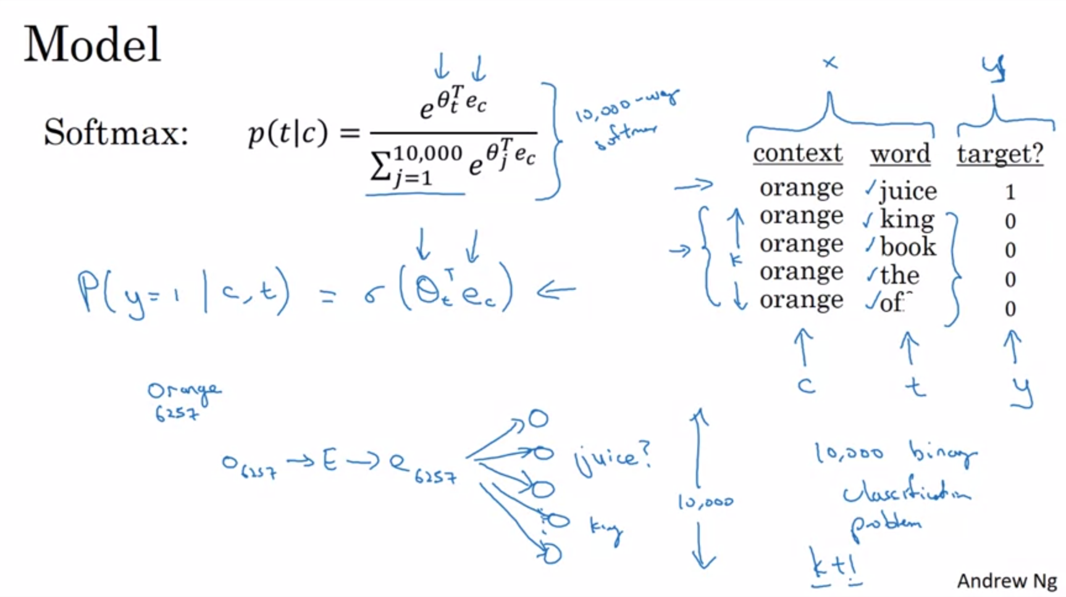

Next let’s describe the supervised learning problem to map from x to y. Define a logistic regression model to estimate the probability that y is equal to 1.

The parameters are similar as before. We have one parameter vector theta for each possible target word and one embedding vector e for each possible context word.

We have a k:1 ratio in terms of negative examples:positive examples.

At the bottom of the slide we have a drawing of this as a neural network. Think of it as having 10k logistic regression outputs (binary logistic regression classifiers). But instead of training all 10k at every iteration we will only train 5 of them for k=4.

We have turned the 10k-way softmax into 10k binary classification problems, each of which is quite cheap to compute. And on every iteration we will only train k+1 of them. That is why the computational cost of this algorithm is much lower.

This technique is called negative sampling (we deliberately created a bunch of negative examples for each positive example).

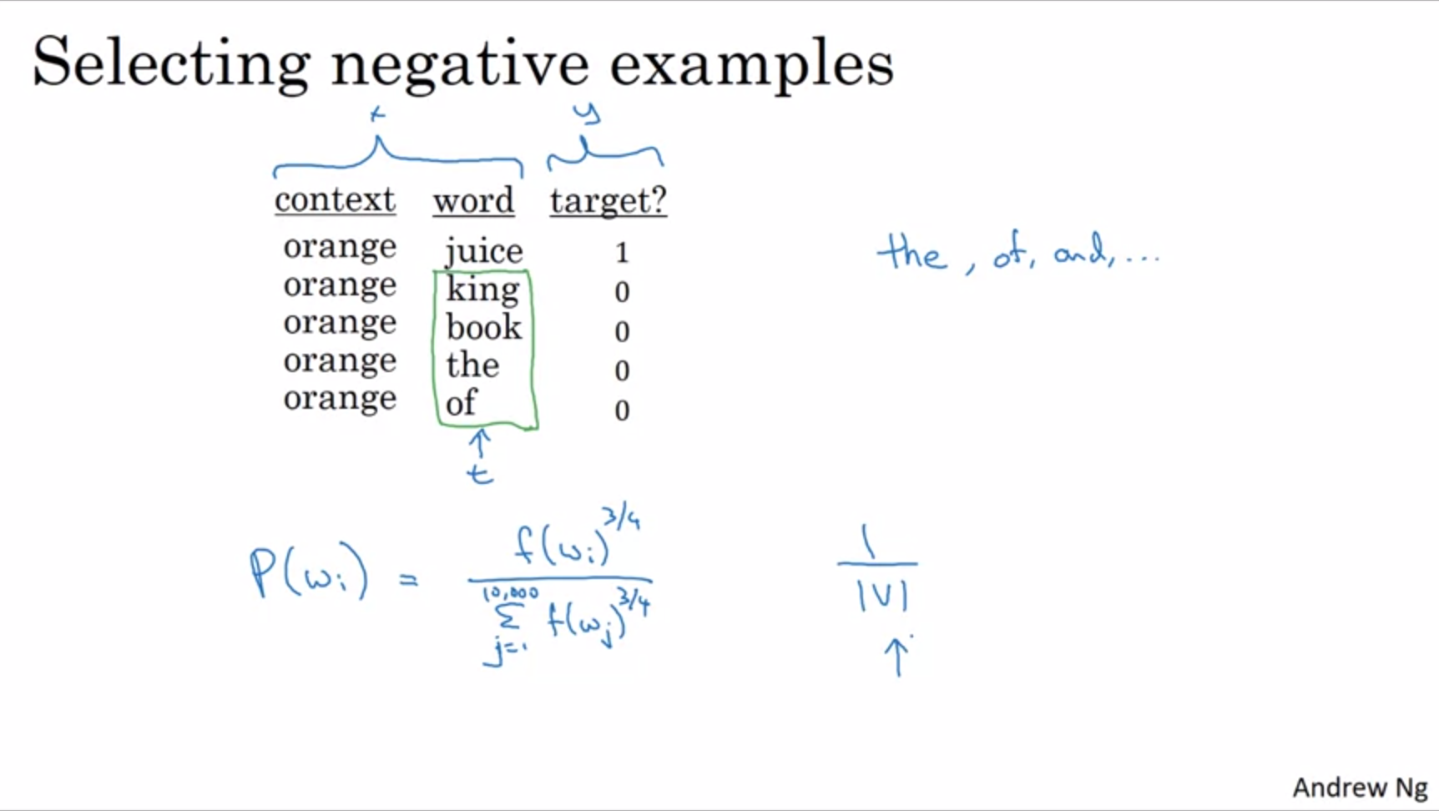

How to choose negative examples?

Sample the target word according to the empirical frequency in the corpus. Problem with that is that “the”, “of”, “and” will occur very often.

One other extreme would be to use 1 over the vocab size and sample negative examples uniformly at random. But that is not very representational of the distribution of English words.

What the authors of the paper reported is that empirically above formula / heuristic value worked quite well (which is between the two extremes). Sample proportional to the frequency of a word to the power of (3/4)s.

This will be somewhere in between the extreme of taking the uniform distribution and the extreme of just taking the observed distribution in the training set. It is not really theoretically justified but multiple researchers have adopted this.

Summary: negative sampling is much more efficient way of creating word embeddings since softmax is replaced with binary classifiers. This will also result in pretty good word vectors.

There are open source implementations and there are also pretrained word vectors that others have trained and published under permissive licenses.

Next we are looking at another algorithm next to the word2vec skipgram which is even simpler than what we have seen so far.



Another algorithm that has some momentum in the NLP community to calculate word embeddings. It is not yet used as often as word2vec but it is supported by some enthusiasts (in part because of its simplicity).

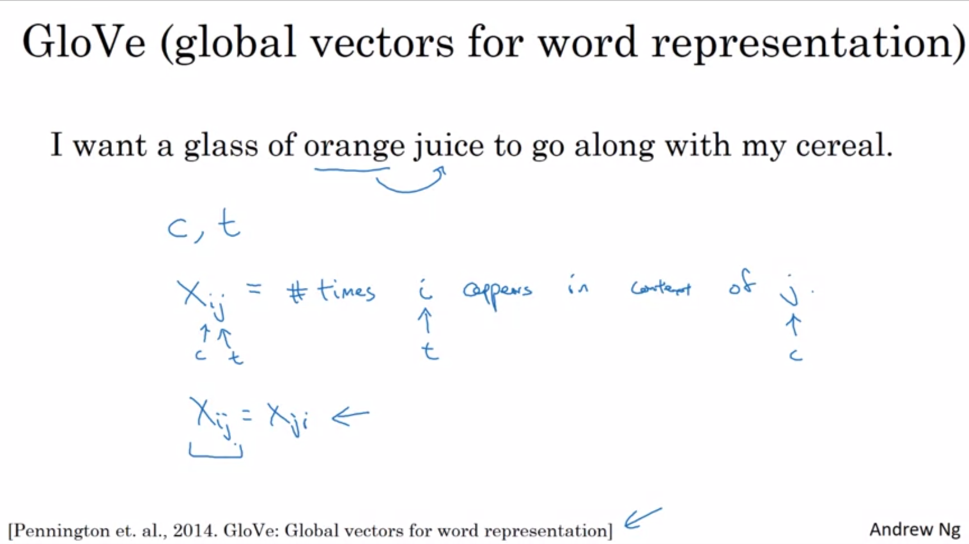

The GloVe algorithm was created by the authors of the paper on the slide.

Previously we were picking context and target words by picking words that are in close proximity.

The GloVe algorithm starts off by making that explicit.

j and i play the role of t and c.

Depending on the definition of context and target word, Xij might equal Xji. If context and target are defined as whether they appear within a window of 10 words it would be a symmetric relationship. If context is defined as being the word in front of the target word, then it would not be a symmetric relationship.

In the context of GloVe we will make use of the first definition (whether words appear in close proximity to each other).

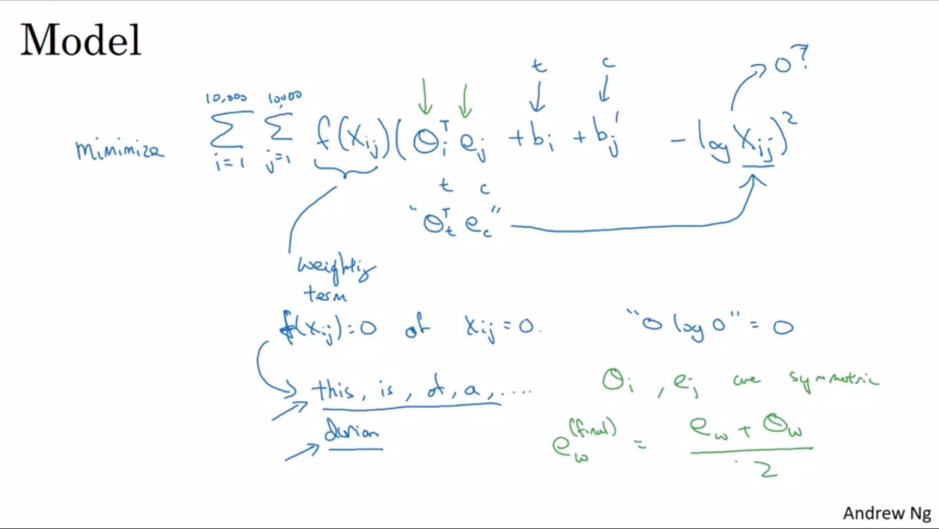

Theta_i multiplied by e_j -> how related are words I and j. We want to have the inner product to be a good predictor for how often these words occur together (Xij).

We use gradient descent to solve for theta and e by minimizing the difference over all the words.

Weighting term is added which is 0 if Xij=0 (words need to have cooccurred at least once to be considered). Also weighting term can be used to give importance also to some less frequently occurring words such as durian and give less weight to stopwords.

Theta_i and e_j are now completely symmetric. If you look at the math they play now the same role.

One way to train the algorithm is to initialize theta and e both uniformly at random, run gradient descent to minimize the objective and when you are done for every word take the average (since theta and e now play the same role).

One “confusing” part about GloVe is that it seems almost to simple to learn useful word embeddings but it turns out that this works quite well. This algorithm came later after all the algorithms seen earlier.

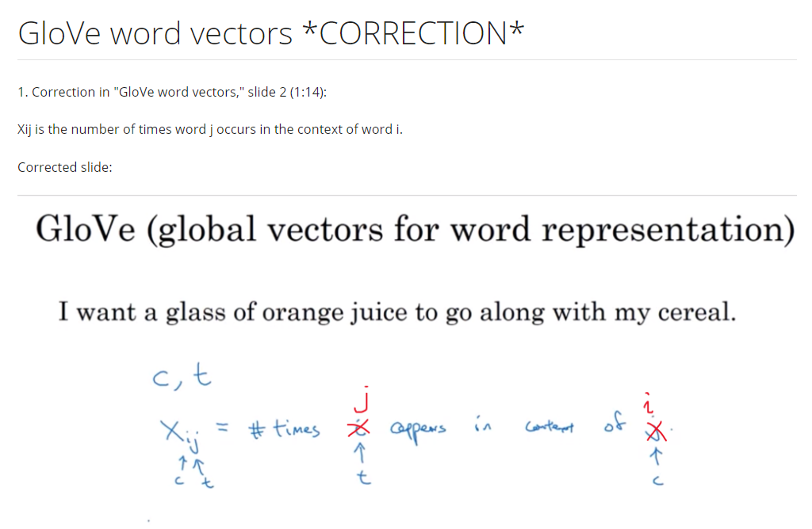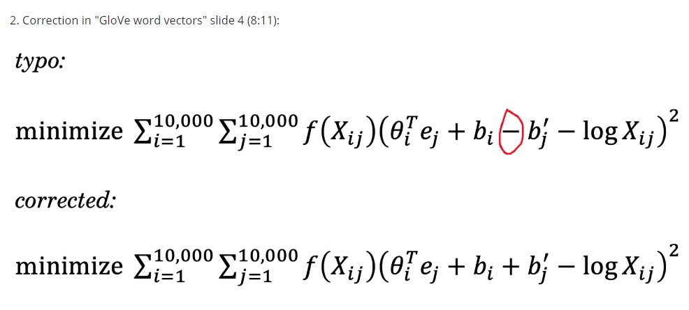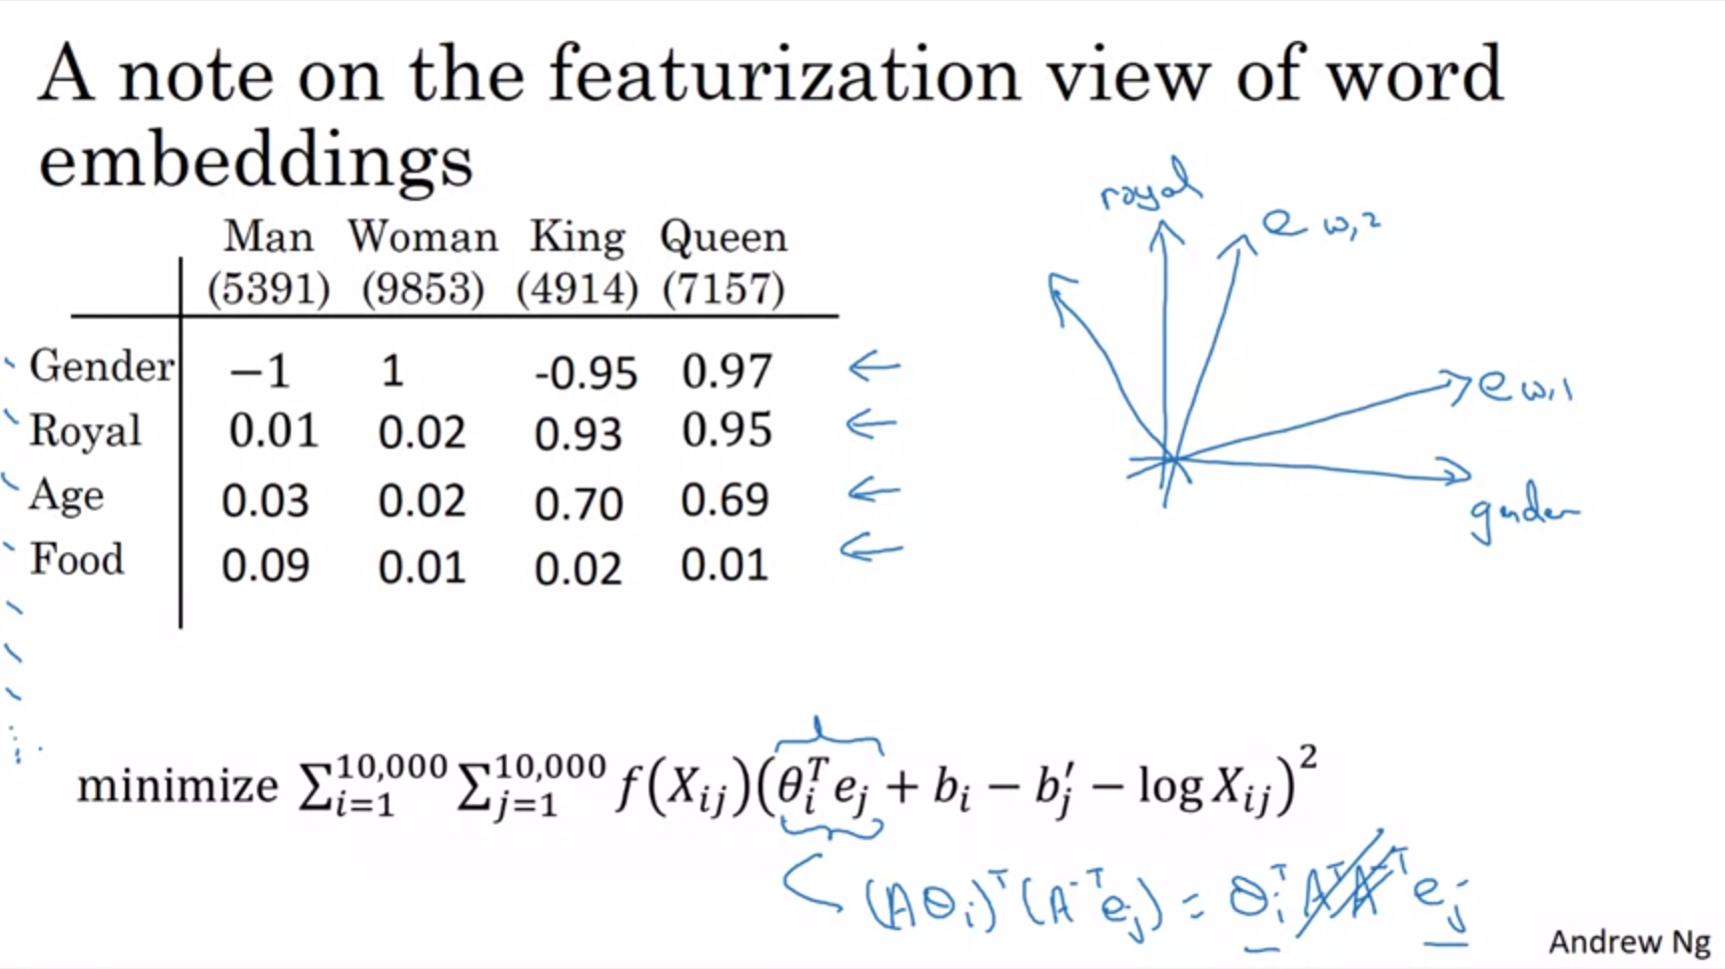

We started off with this featurization view as the motivation for learning word vectors.

When you learn a word embedding with one of the algorithms that we have seen, e.g. GloVe, what happens is that you cannot guarantee that the individual components of the embedding are interpretable.

The axes of the embedding vector are not aligned with axes of meaning. It might not even be orthogonal.

Brief linear algebra proof that axes do not have to be aligned with what is human interpretable: you can multiply theta by a matrix A and e by A inverse and they will cancel out.

The first feature can be a combination of all of these human interpretable features like gender, royal, age, food.

The parallelogram of analogies still works after these linear transformations of features.

Next we will see how these algorithms can be used to carry out sentiment classification.